Q2) Serverless API

Creating lambda functions get, post, delete, put

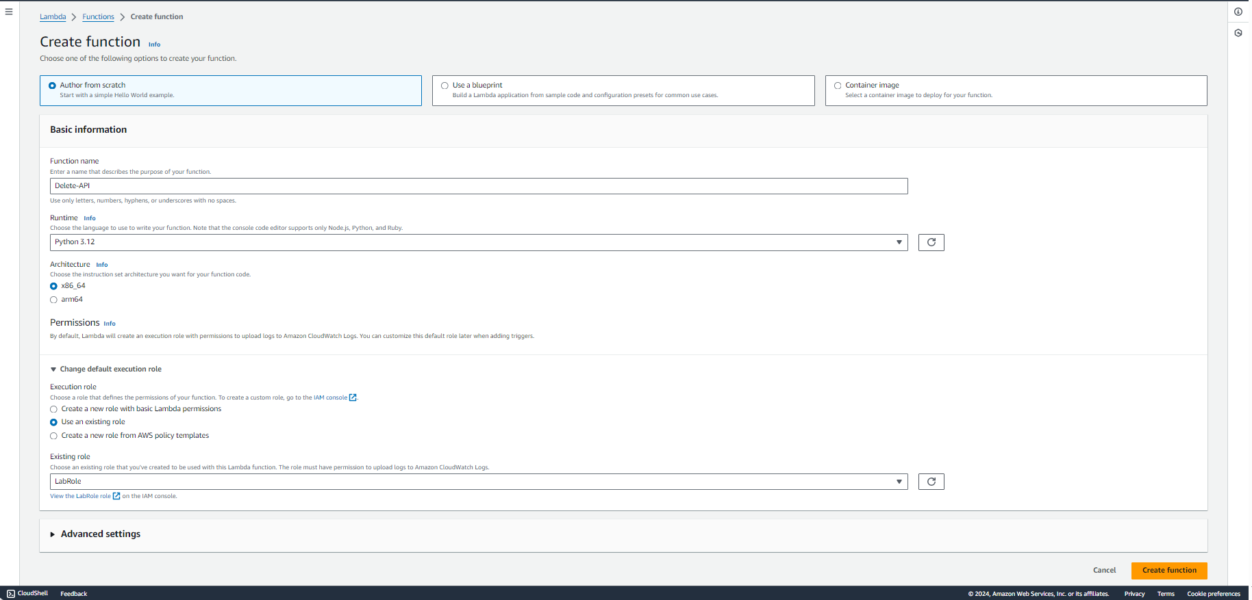

Creating RestAPI

Creating Resource

Creating Get Method

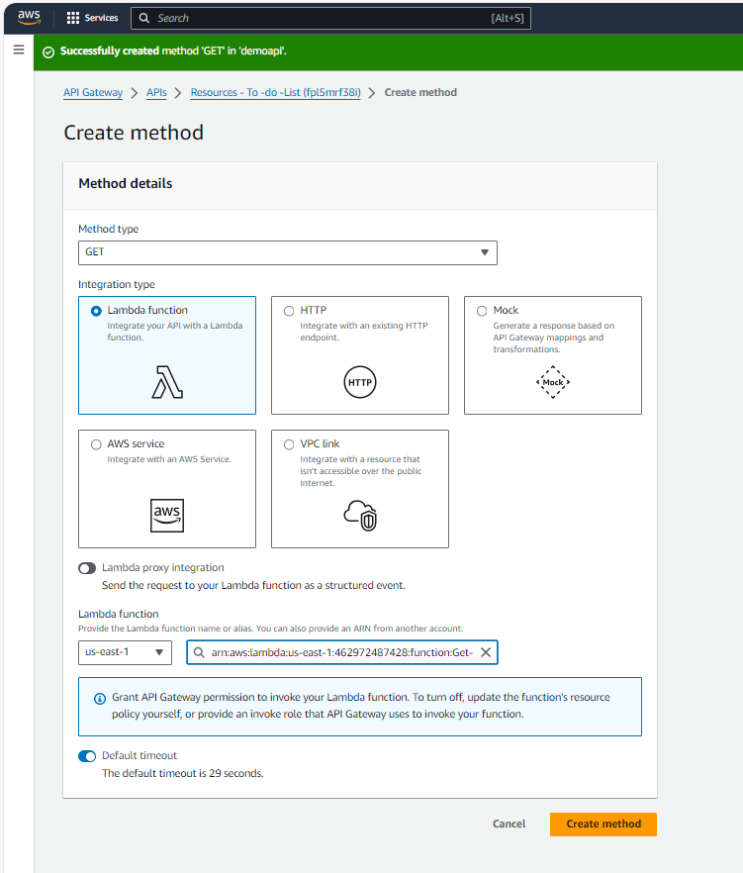

API Gateway add in lambda function after creating method in resource

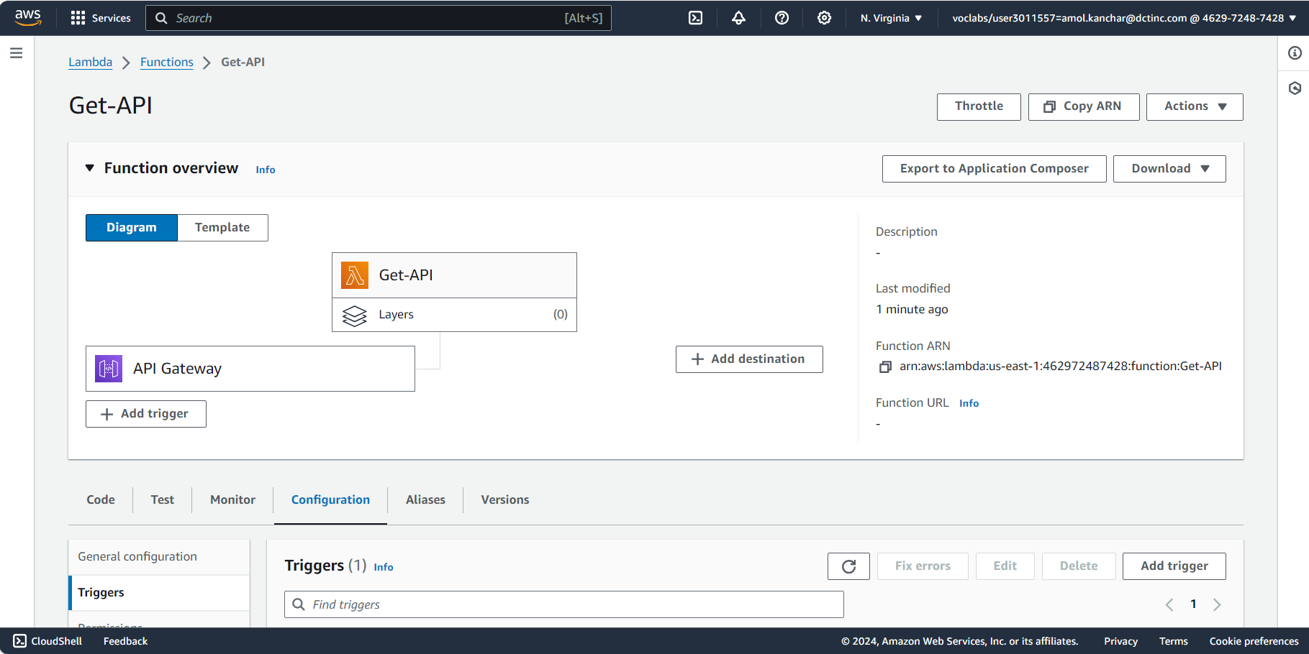

Creating Stage

Adding Resource name at last to see output which I have write in lambda function

Creating Post Method

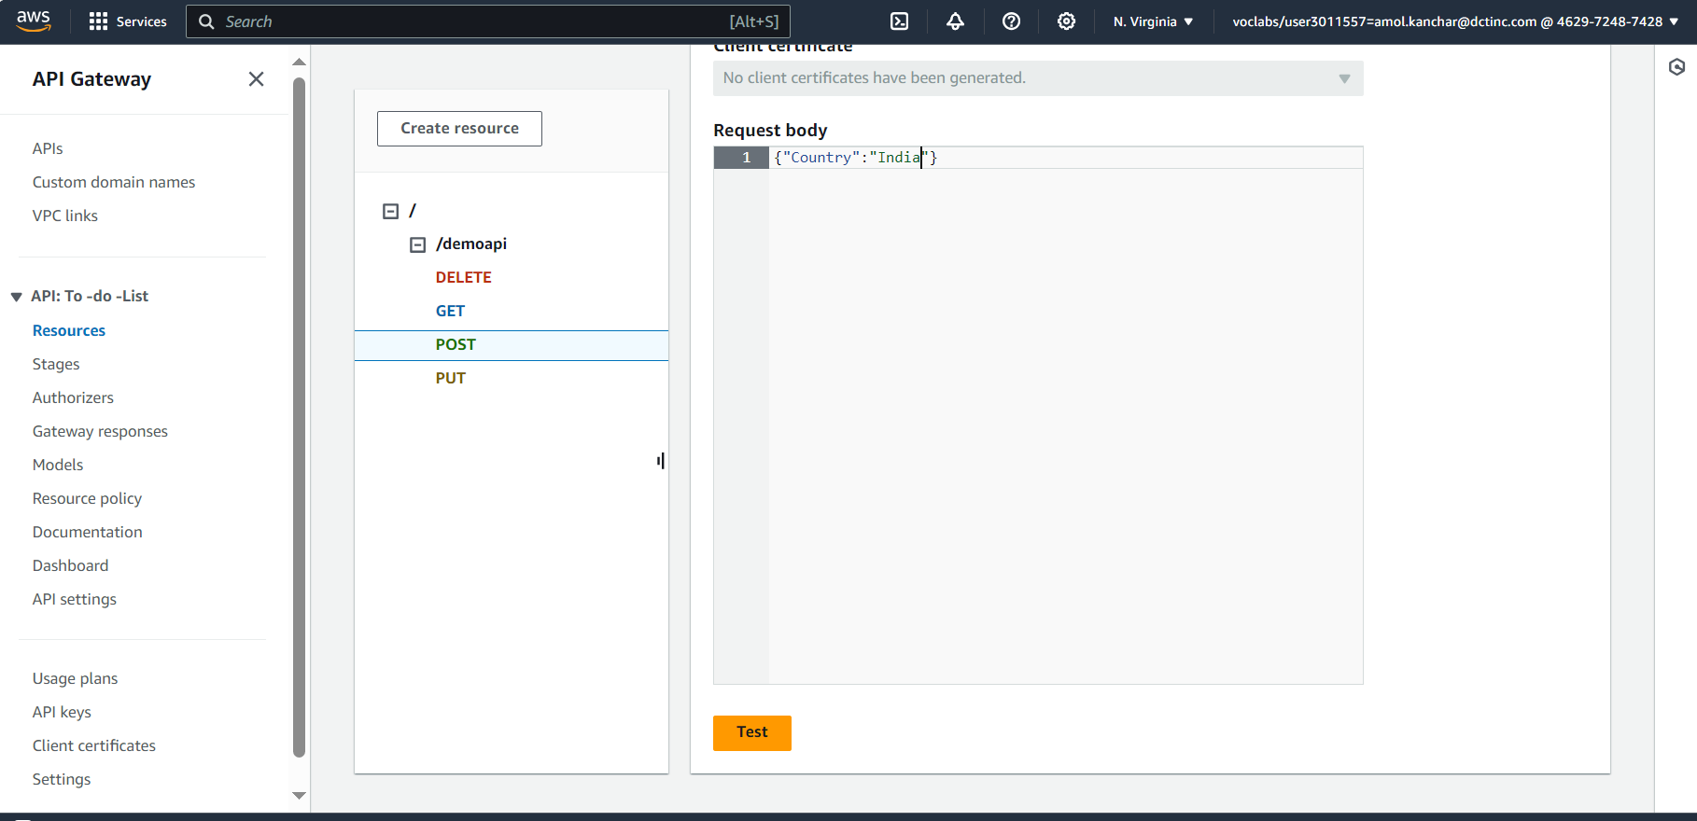

Creating Put Method

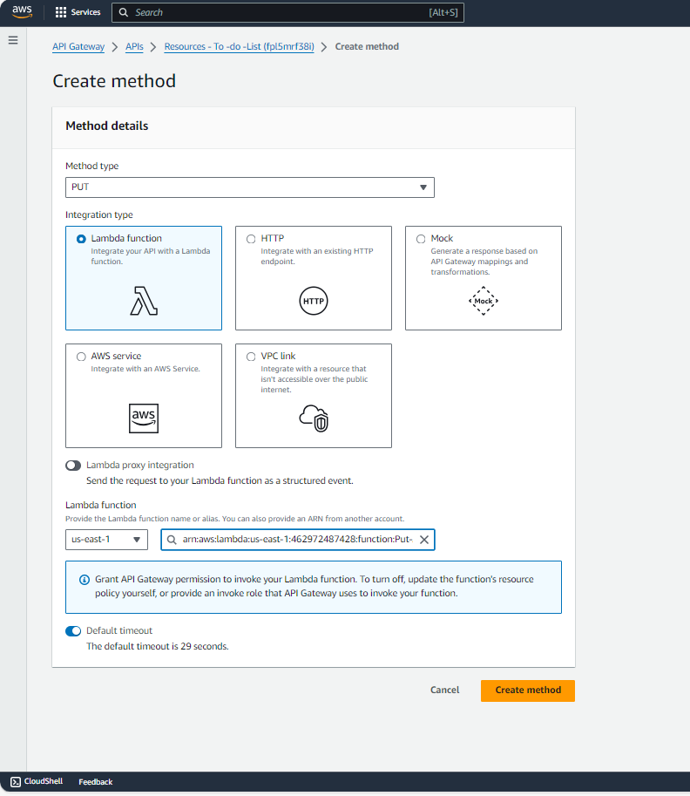

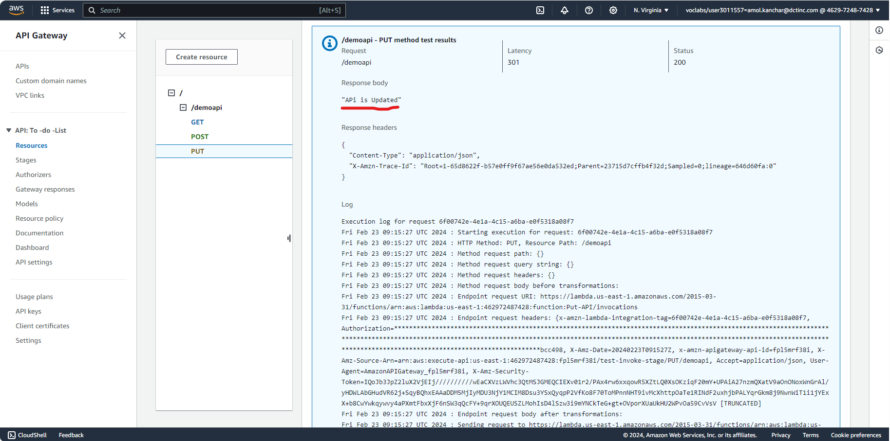

Creating Delete Method

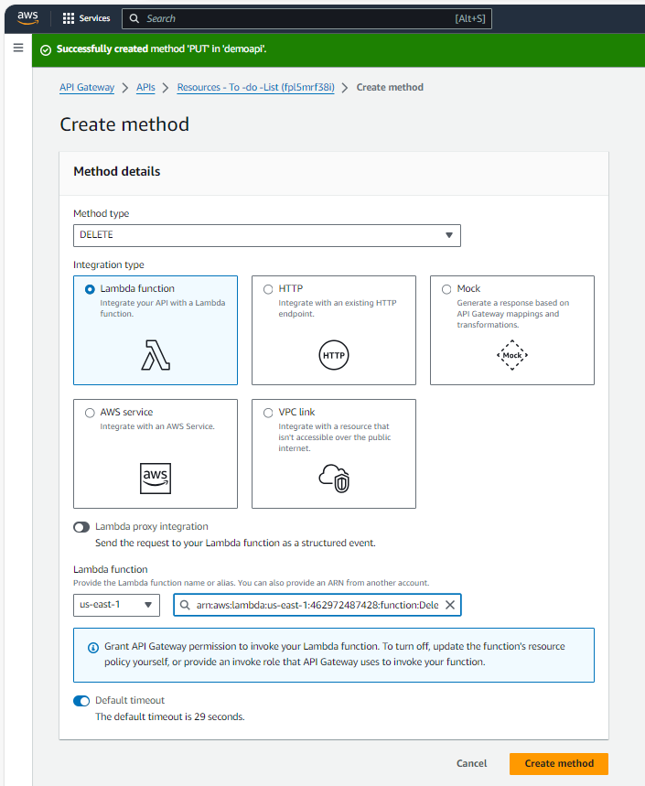

Q3)

Creating three S3 buckets

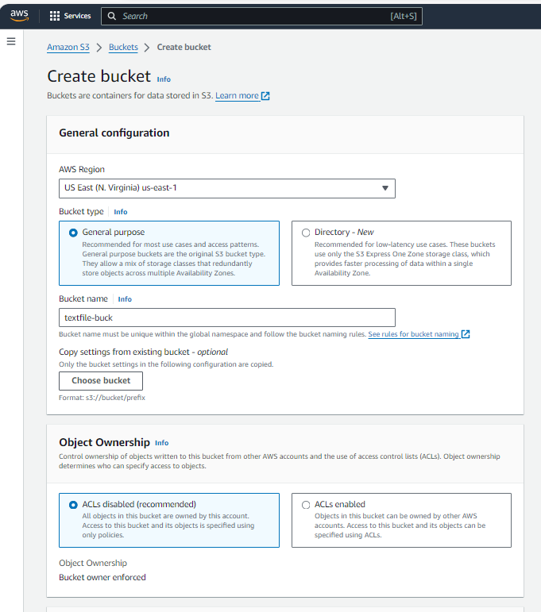

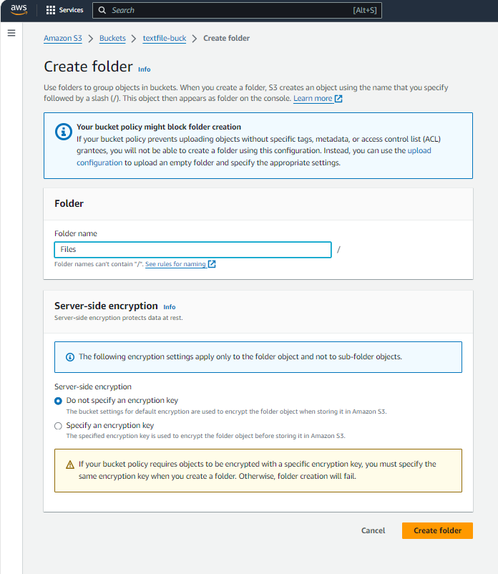

Creating Lambda Function

Trigger Added Successfully



